**Jenkins Master and Slave Concept**

A Jenkins master comes with the basic installation of Jenkins, and in this configuration, the master handles all the tasks for your build system.

If you are working on multiple projects, you may run multiple jobs on each project. Some projects need to run on some nodes, and in this process, we need to configure slaves. [Jenkins slaves connect to the Jenkins master](https://dzone.com/articles/asynchronous-master-slave-replication-of-postgresq) using the Java Network Launch Protocol.

**Jenkins Master and Slave Architecture**

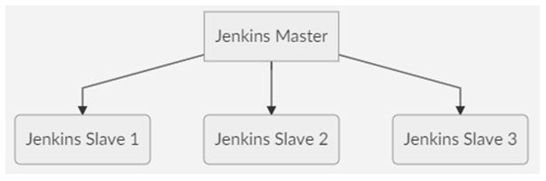

**Jenkins slave1**

1.Create one instance in Jenkins server2.Create one new instance ubuntu serverGo to terminal ubuntu server connect$ sudo apt update $ java –version$ pwd (/ubuntu/home/)$ sudo mkdir Jenkins $ sudo chmod 777 -R Jenkins$ ls$ cd jenkinsLs $ Pwd (/ ubuntu/home/Jenkins/)

**Jenkins master**

1.Open dashboard2.Go to manage jenkins3.Click manage node and clouds4.New node click 5.Name (jenkins -slave-1)6.Click permanent agent7.Number of ececutors (how many jobs )8.Remote root directoey :/ubuntu/home/jenkins/9.Lables -> jenkins-slaves -110.Usage : use the node as must as possible 11.Launch methed:launch agents via ssh

1. Host: new instance ip public13.Credentials:14.Kind: ssh username with private key15.Id: jenkins-slave-116.Descriptions: jenkins=slave-117.Username :ubuntu18.Private key:19.Click enter directory (add copy pem.key paste)20.Save credentials21.Host key verification stategy: non verify ication stategy

https://www.bogotobogo.com/DevOps/Jenkins/Jenkins_on_EC2_setting_up_master_slaves.php